1. Write a program to create a class named Validator and define a static method that checks whether a password is strong.
Criteria used:
- Minimum 8 characters
- At least one uppercase letter
- At least one lowercase letter
- At least one digit
- At least one special character
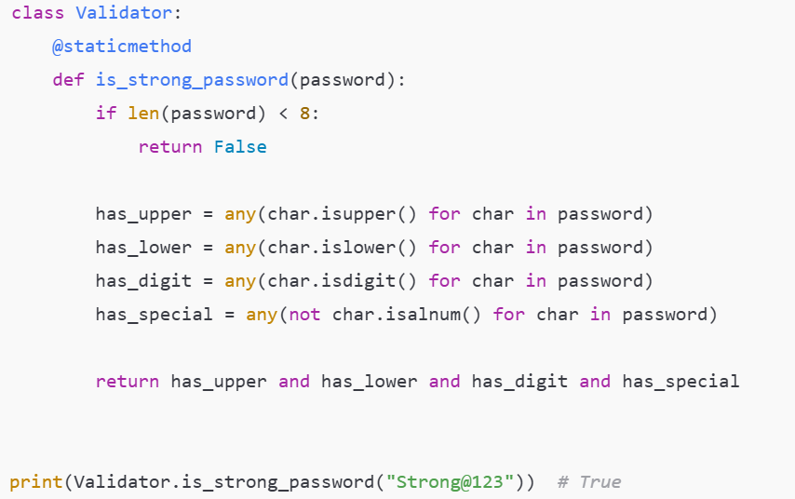

2. Write a program where a static method converts temperature from Celsius to Fahrenheit and Fahrenheit to Celsius.
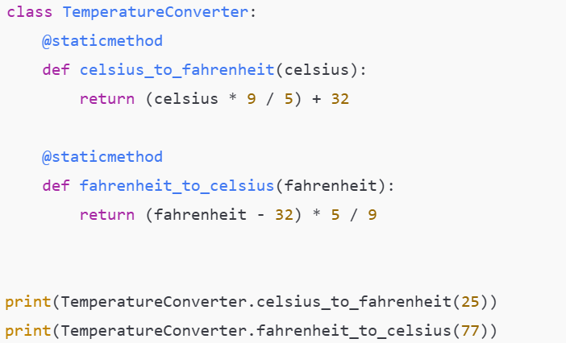

3. Write a program to create a Utility class with a static method that checks whether a given year is a leap year.
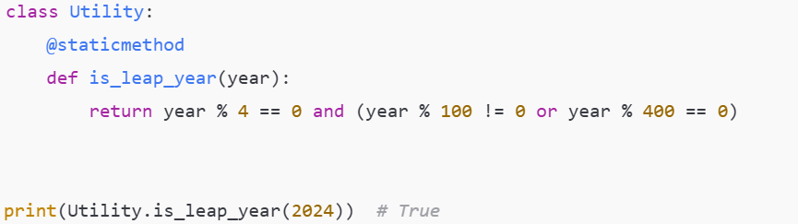

4. Write a program to validate a product code using a static method with a predefined format.
Format assumed: PROD-XXXX (PROD- followed by exactly 4 digits)
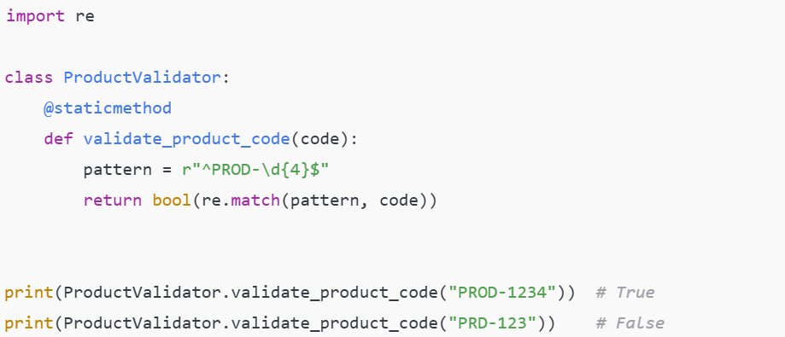

5. Write a program that demonstrates reuse of a static method across two different classes.
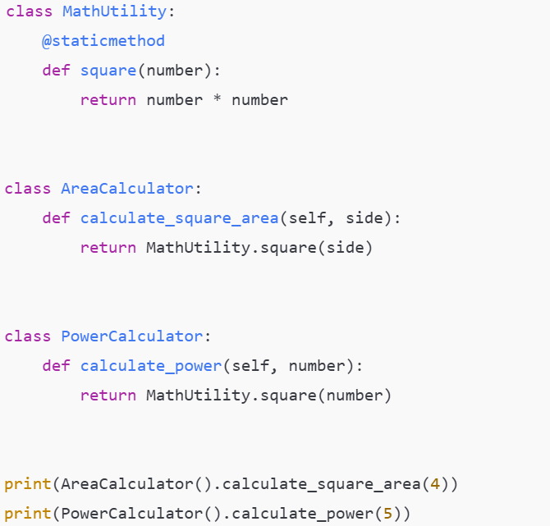

6. Write a program to create a Student class and use a class method to count the number of student objects created.
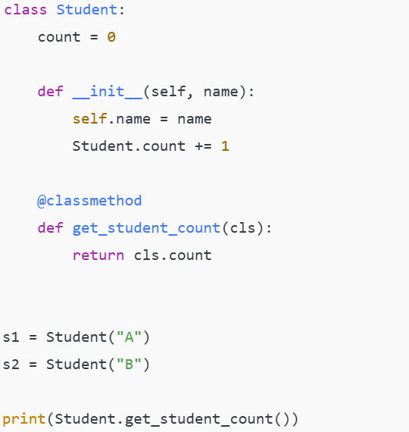

7. Write a program where a class method works as a factory method to create objects from dictionary data.
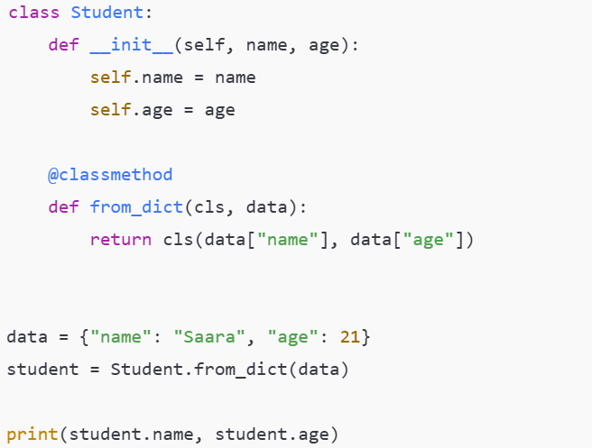

8. Write a program to create a Bank class where the interest rate is shared and updated using a class method.
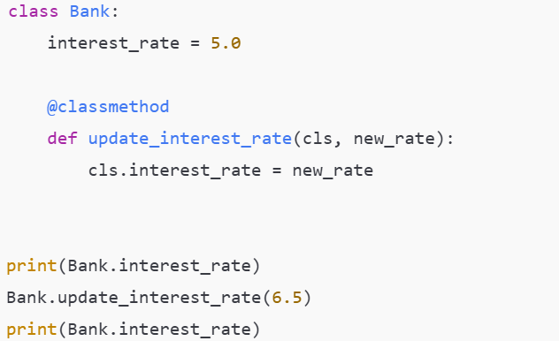
9. Write a program to demonstrate how a class method behaves when called from a child class.
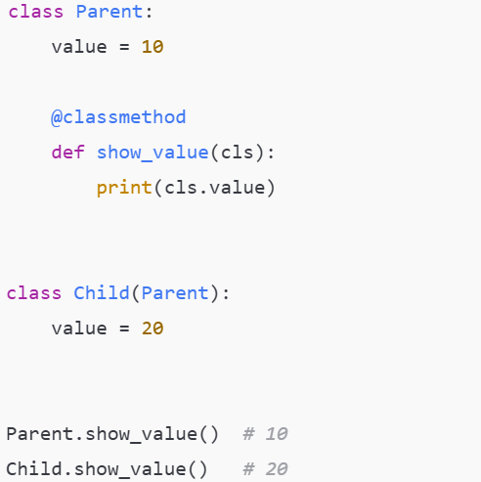

10. Write a program where a class method resets all class level data.
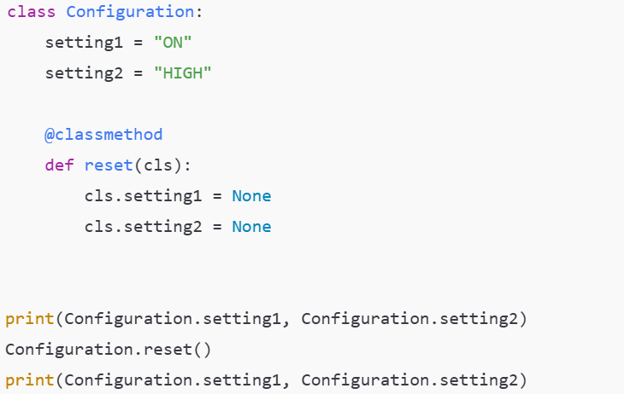

11. Write a program to create a BankAccount class and perform interest calculation using a private method.
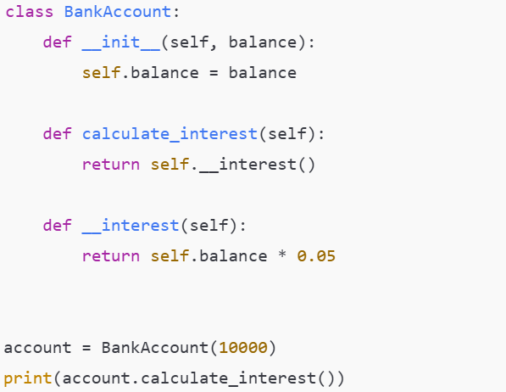
12. Write a program where a public method internally calls a private method for validation.
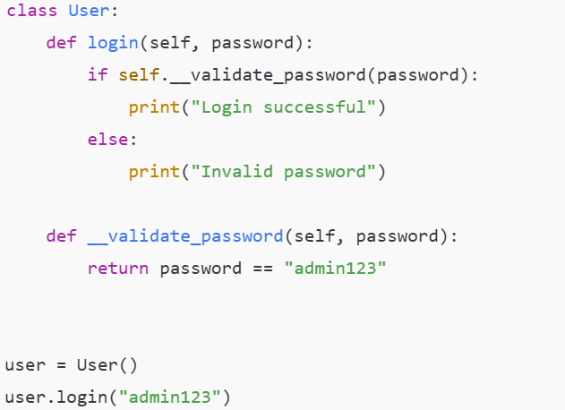

13. Write a program to demonstrate that a private method cannot be accessed directly outside the class.
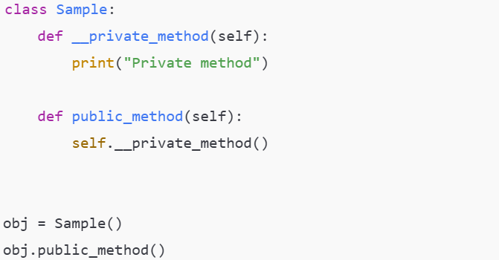

14. Write a program to demonstrate name mangling behavior of private methods.
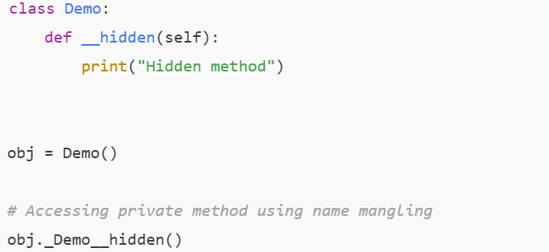

15. Write a program where changes in a private method do not affect external code.
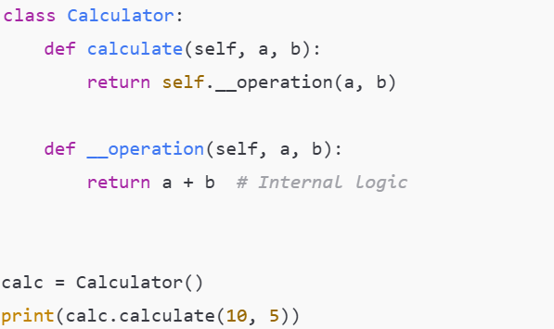

16. Write a program to create an Employee class and update salary using an instance method.
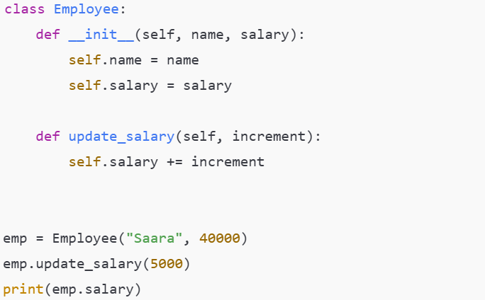

17. Write a program where an instance method modifies both instance level and class level variables.
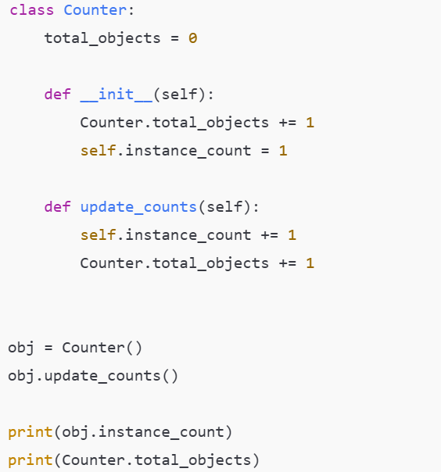

18. Write a program that shows an error when an instance method is called without creating an object.
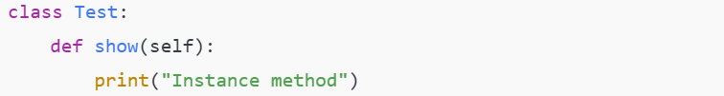

19. Write a program to create an instance method that returns calculated data based on object attributes.
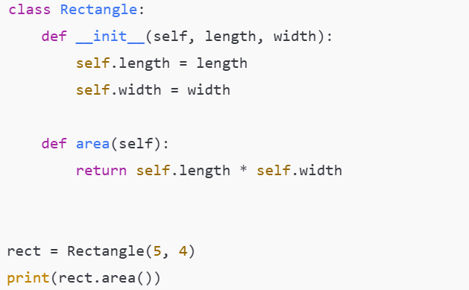

20. Write a program to override an instance method in a child class and call the parent method using super.
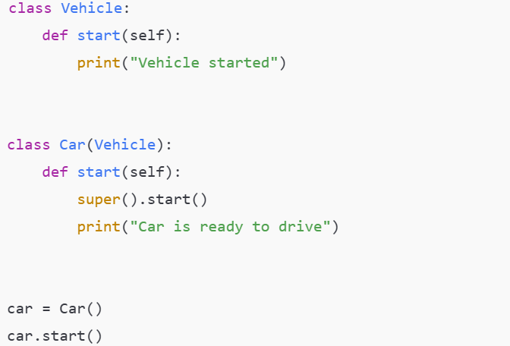

21. Write a program to create multiple objects from the same class and show that they store different data.
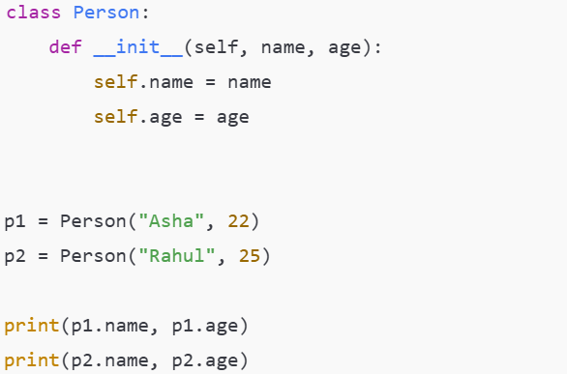

22. Write a program to demonstrate the difference between class variables and instance variables.
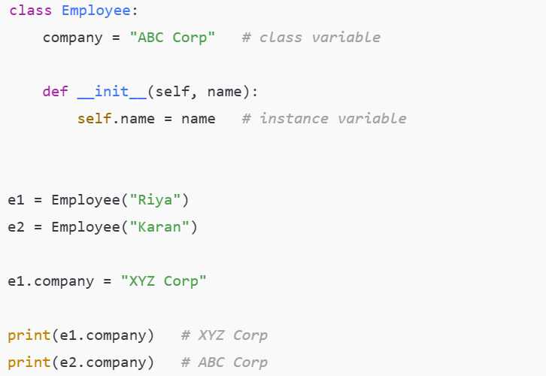

23. Write a program to create a class without a constructor and assign attributes dynamically.
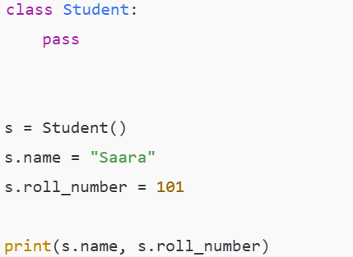

24. Write a program to demonstrate object reference assignment and shared references.
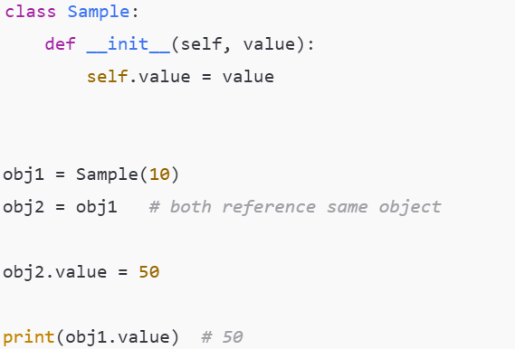

25. Write a program to demonstrate object deletion and its effect.
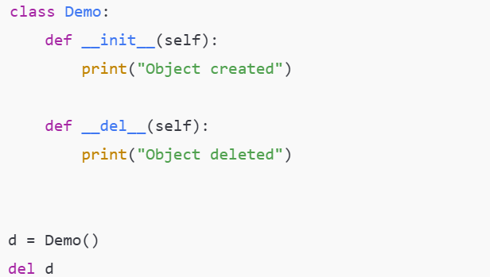

26. Write a program to demonstrate single inheritance using a parent and child class.
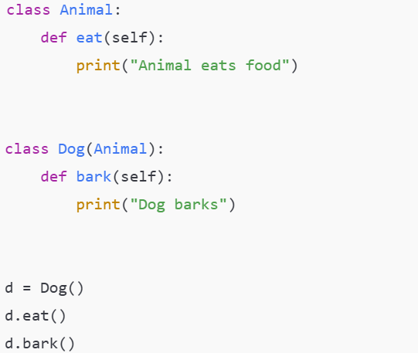

27. Write a program to override a parent class method in a child class and change its behavior.
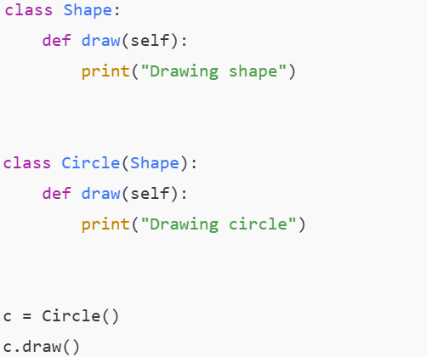

28. Write a program to demonstrate inheritance and method overriding together.
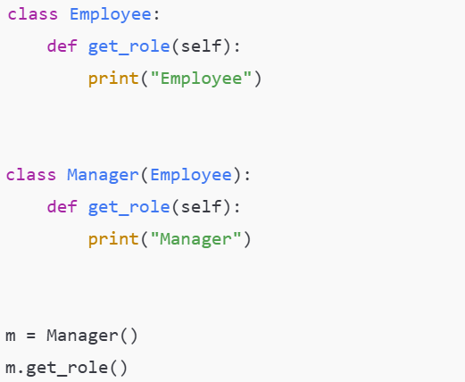

29. Write a program to demonstrate how super works inside a child class constructor.
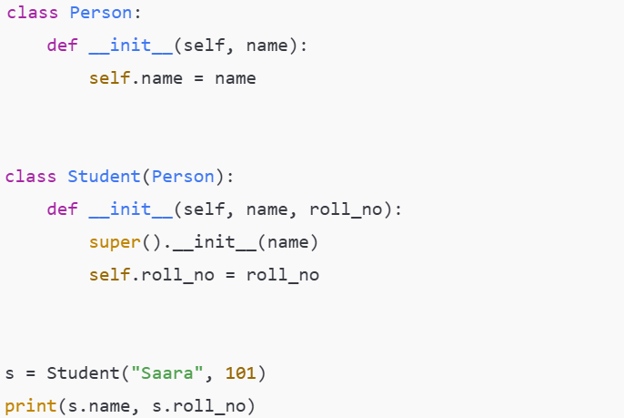

30. Write a program where a child class extends functionality without modifying the parent class.
